Slide 1 - Slide 1
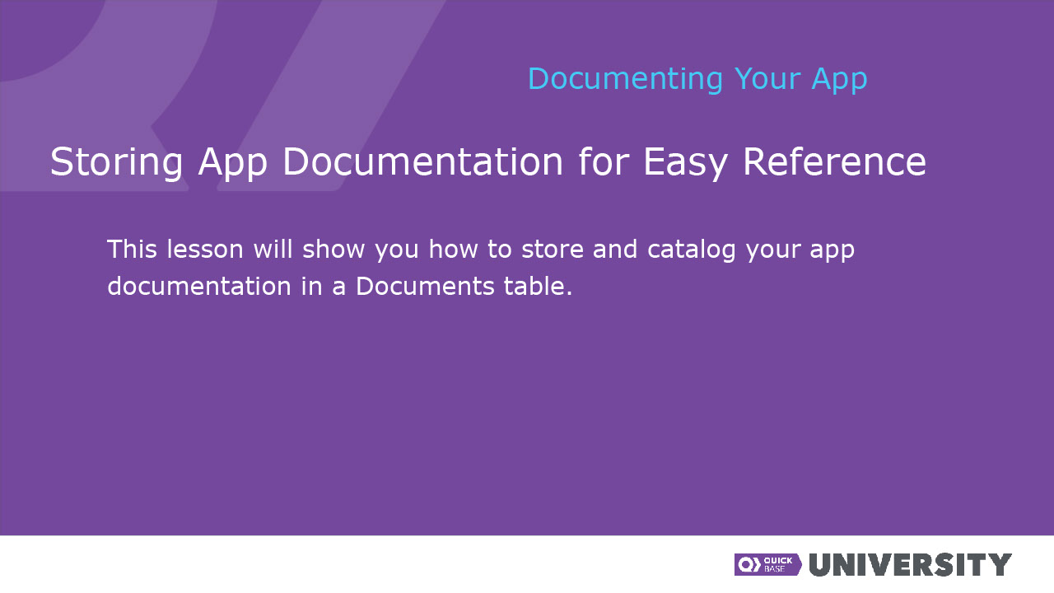
Narration

Slide 2 - Slide 2
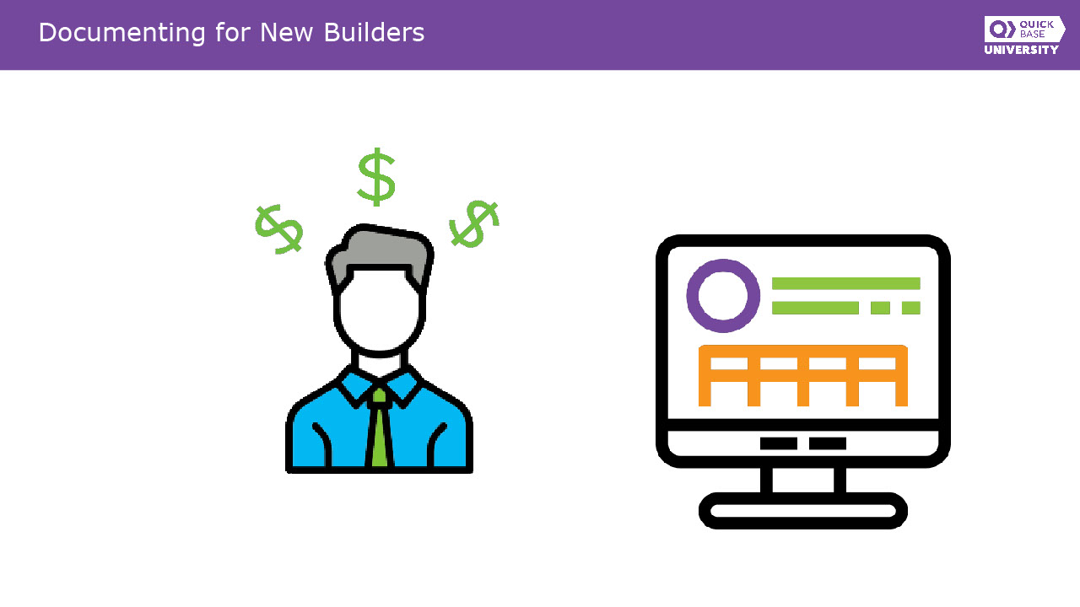
Narration

Now that we’ve discussed why we document, let’s talk about what we should document and where we should store our documentation. Assume you won the lottery. (Hey, someone always wins. Why not you?). You’ve left the organization to go live in the south of France. Now there’s a new admin for the app. She’ll probably have a few questions like, “What’s the purpose of the app?”, “Who’s currently using it?” and “Where can I find the app’s documentation?”

Slide 3 - Slide 3
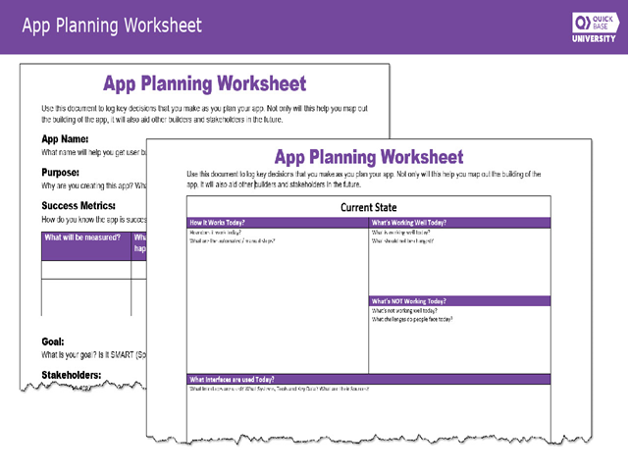
Narration

Perhaps you filled out an app planning worksheet when you created the app. This worksheet helped you map and plan the app’s design. Two worksheet templates are included in the lesson resources.

Slide 4 - Slide 4
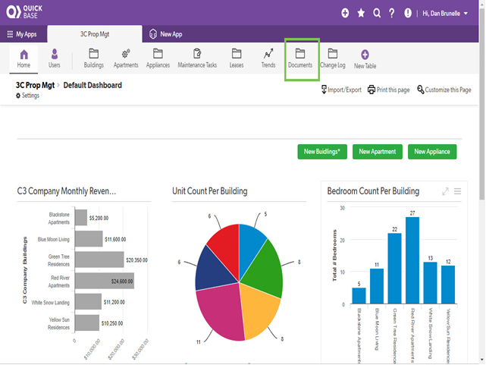
Narration

So where should you store the worksheet for easy access? How about in a Documents table in the app? A table like this is the best way to collect documents related to the app’s planning and building. Because it’s a table, it’s easy for builders to access and use. If you want, you can limit access to builders, admins, or other specific roles.

Slide 5 - Slide 5
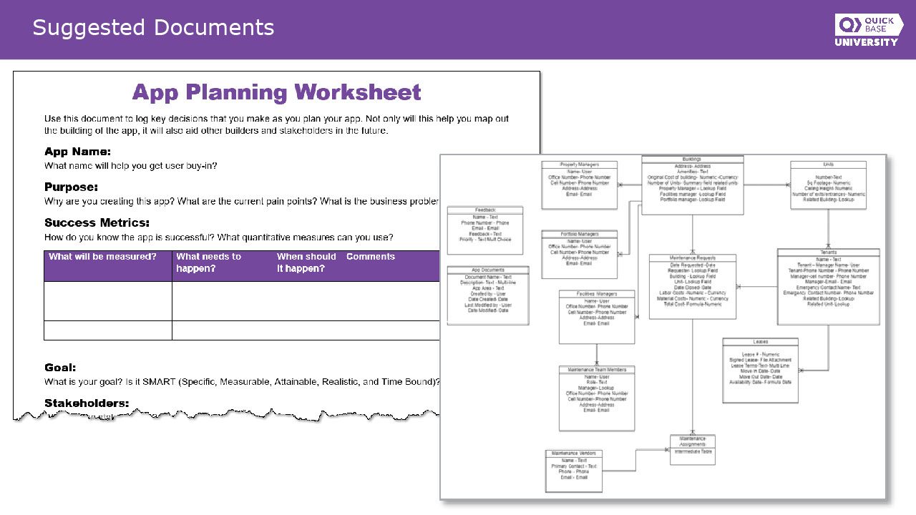
Narration

Use the table to house the important documents you created and used when you built the app, like the planning worksheet and the app diagram, which is where your table relationships are mapped out. Other documents for this table can include the roles matrix, the requirements document, and the naming conventions document.

Slide 6 - Slide 6
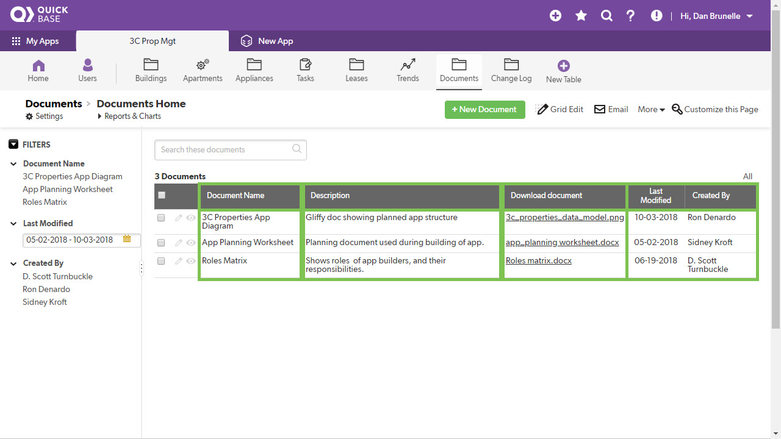
Narration

Let’s have a closer look at the table. Notice the fields. Included in the table are fields for the document’s name, description, and a download link. In addition, there is a date field as well as the name of the doc’s owner.

Slide 7 - Slide 7
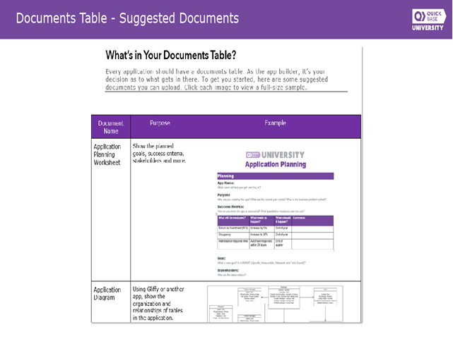
Narration

What you store in your own documents table is ultimately up to you. However, we’ve prepared a brief list of suggested documents that you can use as resources for yourself and other builders. You can access this list in the lesson resources.

Slide 8 - Slide 8
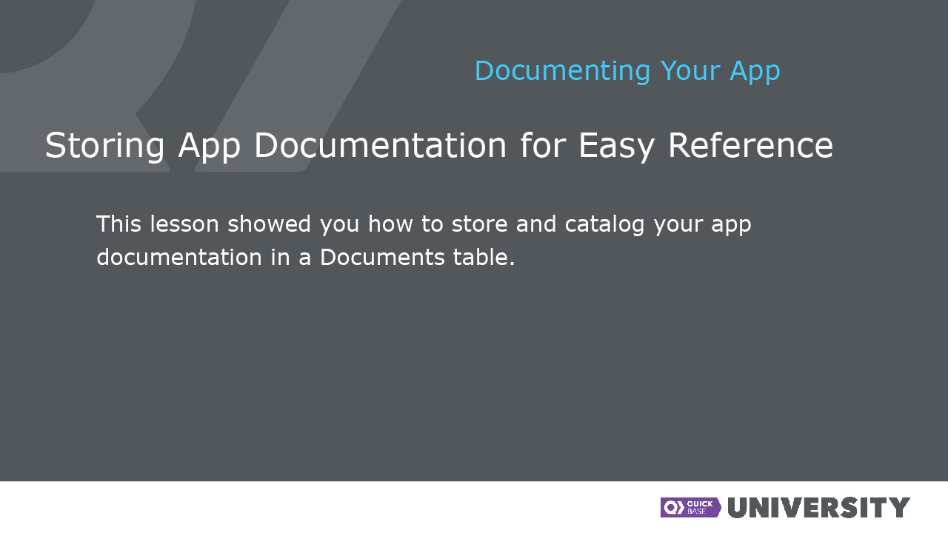
Narration

