VeilSun, Inc. is a business consulting and web platform firm specializing in Intuit’s QuickBase online Database
We combine sound business know-how, creativity and QuickBase expertise to go beyond traditional consulting, providing powerful web-based solutions for a wide range of businesses.
Denver ▪ Houston
p. 855.702.1976
www.veilsun.com
Facing an aggressive growth strategy and sudden demand brought on by Hurricane Sandy, this company needed to scale, and scale fast.
Solar Company Growth Goes “Through the Roof” with VeilSun and QuickBase

Over a year ago Roof Diagnostics (RDI), a leading Home Solar Integration company was poised for significant growth. Headquartered in New Jersey, their business was about to double in size and move into four more states - a storm was brewing.
Problem: Scaling Growth
RDI had a good recipe for success with an outstanding delivery reputation in their state and an innovative way to introduce new customers to their products and services. In order to realize their innovative growth plans, they realized they would need to make major process improvements. They were managing the whole business on spreadsheets and free web services and in order to maintain their level of delivery and satisfaction, they knew they would need to centralize their workflow into a single system.
“The typical CRM solutions on the market did not feel right for our business. Our business is unique and progressive- we didn’t want a cookie cutter solution,” said Kelcy Pegler Jr. “It was important that our software platform provided the information and process framework to reflect our business and its fast, real-time pace. Without QuickBase this would not have been possible.”
2012 provided explosive growth for RDI, increasing revenues from $8m in 2011 to $31m in 2012. Roof Diagnostics would need to move quickly to prepare for both planned and unplanned growth and propel them into market leading performance.
Puzzle Pieces
Being a technology visionary, Kelcy Pegler Jr., Co-Founder and CEO, tasked his IT partner, TechPromise (http://www.techpromise.com ), to find an answer to their current pains and projected growth through use of a flexible cloud platform, and to find a partner to implement it. Enter QuickBase and VeilSun.
“We had to find something that we could bring up fairly quickly and would be flexible and scalable”, remembers Mike Grossman, owner of TechPromise. “We realized quickly that QuickBase was our answer. We then realized we need help building and integrating the system so sought out a partner expert. We shopped very hard and VeilSun was the other piece of the important puzzle. We knew we needed them to put it all together correctly”.

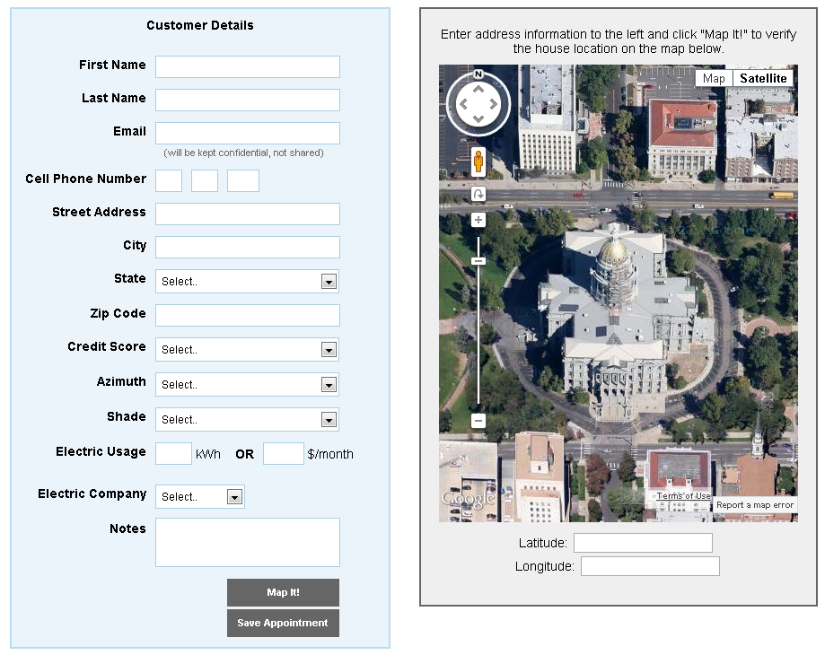
The QuickBase Solution
VeilSun responded and held a workshop with Roof Diagnostics to define their workflow and needs. Within a few weeks, VeilSun was able to release an initial QuickBase application to replace the company’s currently distributed lead tracking system that sat in major big box stores around the area.
In-Store Appointment Scheduling (see screenshot 1)
Leveraging QuickBase integrated with Google Maps, the system could be accessed in-store by representatives to
- Enter customer information
- Set solar appointments for customers based on Roof Diagnostic resource availability
Screenshot 1
- Verify the home location with the customer via map pin on a Google Map in order to reduce missed appointments
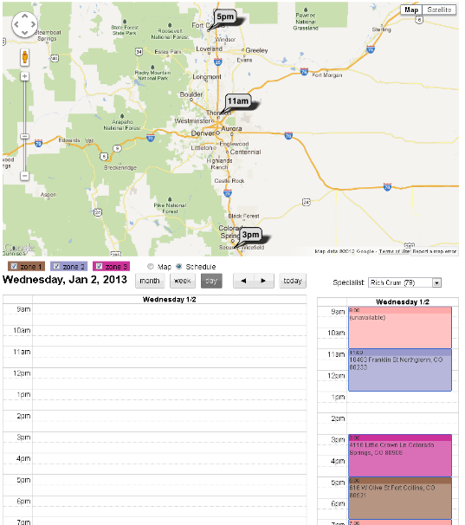
- Leverage satellite photos to create estimates, cutting lead-to-close time by 100% and improving customer satisfaction through fewer needed appointments
Scheduling (see screenshot 2)
Another significant challenge was matching scheduled appointments with available reps. To solve this, VeilSun created specialized screens matching up rep schedules with maps to enable efficient assignment of appointments.
Using these integrations, they were able to set 50% more appointments per rep, while optimizing logistical costs and were able to track the results of each appointment in real-time. This whole process now took minutes, when it used to take manual effort and hours of consideration.

The Result
The QuickBase application implemented by VeilSun allows RDI to:
  - See the progress of all appointments from a single dashboard so they can address bottlenecks
Screenshot 2
  - Streamline communication through a single operational system
  - Obtain reports easily so they can make data driven management decisions and respond to hot button issues.
Once again, with the help of an expert partner in VeilSun and the workflow capabilities of QuickBase, a business was able to create a platform that reflected their business instead of trying to contort their tasks and processes into an alternative platform. Automating their sales and operations in a short amount of time provided the foundation for Roof Diagnostics to continue to drive their explosive growth.

