QuickBase Online Database

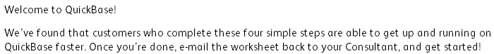







*Type answer here*

*Type answer here*





*Type answer here*





*Type answer here*





*Type answer here*

QuickBase Online Database